Developing a Realtime Weather Model for Unreal Engine 4
Zoe Mershawn, Jon Skinner
Executive Summary—Design and proof-of-concept implementation of a novel system for simulating weather in realtime within Unreal Engine 4. The design is centered around a discrete packet-based simulation of air at the local scale, 1-100 square kilometers, and this simulation is what the artifact implements. The project is complete when the artifact reaches a stage where estimations can be extrapolated about the viability of the proposed design, specifically whether it meets an appropriate standard of design simplicity, system performance cost, and ease-of-use.

Index Terms— Video Game Technology, Technical Art, Weather, Simulation.

INTRODUCTION
Over the past decade, the “Open-World Video Game” has continued to find broad commercial and critical success across the entire market. What was once considered as a passing fad by some has even found its way into recent entries of traditionally linear series like The Legend of Zelda. Indeed, open-world has nearly taken over the industry, ushering in a new era of game technology in the areas of simulation, procedural generation, and advanced rendering techniques, all of which enable studios to create such massive worlds in the first place.
Many of these new technologies fall under the umbrella-category known as Technical Art, where cutting-edge technology and new ideas push both the technological and aesthetic capabilities of gaming further. Over the last few years, a trend has formed within this sector of game technology: the ever-increasing prevalence of simulation. Dynamic Lighting, Physically-Based Rendering, GPU-based particle systems, Fluid Dynamics – all are a part of this trend; in essence, each of these new technologies serve as a replacement for “faking it” with handmade approximations, instead opting to use simulation to represent reality more realistically than ever before.

The author submits the final thesis paper for review on May 2, 2019. This work received no funding and has no conflicts of interest to disclose.
Z. E. Mershawn is a student in the Level Design track at SMU’s Guildhall, 5232 Tennyson Parkway, Building 2, Plano, TX 75024 USA (e-mail: dmershawn@smu.edu)

One such emerging technology is dynamic weather effects. Weather in most modern video games has evolved past the simple animated skyboxes of yesteryear, and there have even been an number of games over the last 5 years that even advertised the quality of their weather as a feature, titles such as Metal Gear Solid 5, Red Dead Redemption 2, and Battlefield 1.
Under the current paradigms that inform the design of weather systems, there are two options when it comes to costs-versus-benefits; either the hand-placement and scripting of hundreds of individual weather effects, or the use of dynamic but simplistic weather effects. Simple weather effects make compromises on the dynamic nature of weather itself in order to maximize reusability throughout the game, running the risk of leaving weather feeling hollow and artificial. Hand-placement on the other hand, while beautiful, can become an extremely tedious and expensive process to implement. This problem can become especially pronounced in the development of open-world games, which already have a significant amount of work necessary to make environments both beautiful and fun.
This thesis introduces a possible alternative; proposing a design for an evolution of weather-technology in video games as we know it, using simulation and real-world values as a basis for a more realistic depiction of not only weather itself, but its nature as a product of the environment around us. This theoretical system would necessitate less work on the part of environmental artists and designers, while also delivering dynamic, realistic-feeling visual effects.
The artifact created for this paper serves as a proof-of-concept implementation of this initial design, using C++ and Unreal Engine 4 to simulate weather in a manner that directly parallels the processes that drive weather in the real world. This paper also includes a postmortem breakdown of the artifact, and an analysis of the lessons that were learned through its creation.
This thesis demonstrates mastery of Technical Art by not only displaying the author’s understanding of the broad set of skills that define a Technical Artist, but also her ability to use those skills to develop novel technologies that solve development problems and push the boundaries of what is possible in video games.

J. Skinner is Level Design professor at SMU’s Guildhall, 5232 Tennyson Parkway, Building 2, Plano, TX 75024 USA (e-mail: jskinner@smu.edu)

Research Review
The research section of this paper serves as brief overview of on the state of modern video game weather effects technologies, through the examination of two titles, an older title from 2015, and a newer title from 2018. In addition to the individual takeaways from each game, the contrast of old against new highlights how the current design paradigm came to be, and how it has changed over the years.
Mad Max [1], released on September 1, 2015, represents an early version of modern dynamic weather system design. While the game does not feature much weather in terms of variety, the game highlights a paradigm shift in weather effects technology: games were starting to more frequently feature weather as a foreground element instead of being a simple piece of scenery, introducing weather-based gameplay elements that further solidified the game’s weather as a powerful and dynamic force.

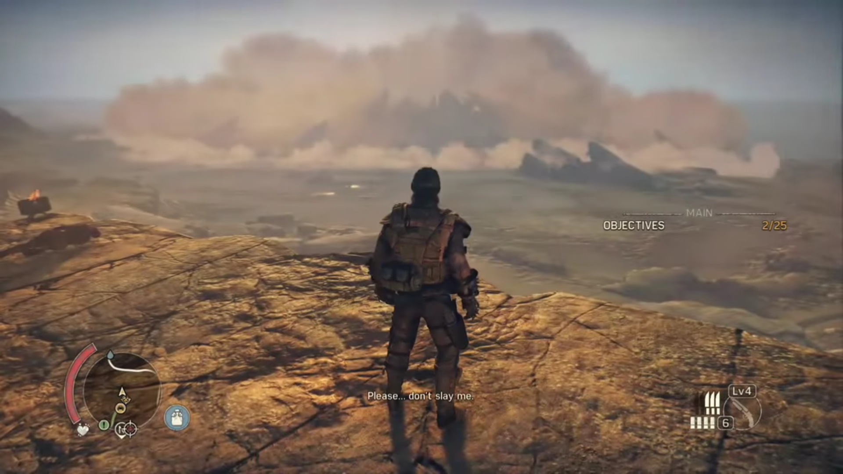
Figure 1: In Mad Max, haboobs can be seen sweeping across the landscape toward the player, the shape dynamically conforming to features of the landscape [2]
While many of the weather effects are simpler than more recent titles [3], others are more complex, even including some dynamic effects such as the crawling haboob of a sandstorm [2].
While many of these weather effects are significantly less sophisticated than more modern effects, they likely took just as much if not more time and resources to implement.

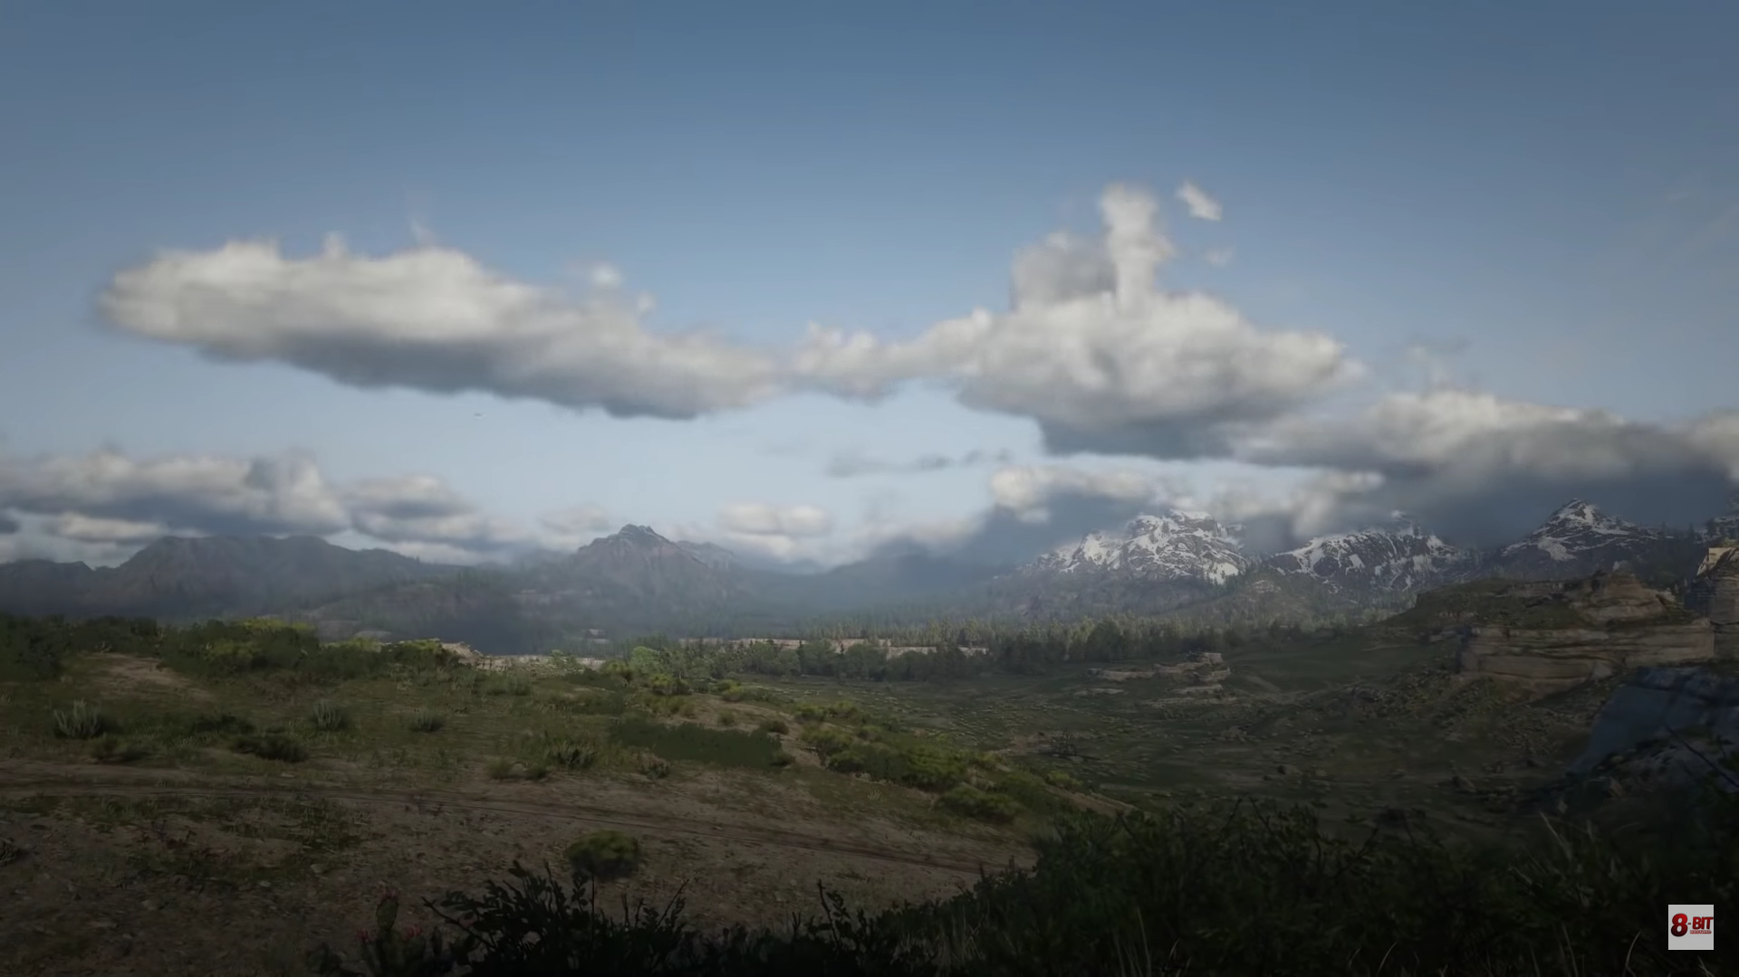
Figure 2: Clouds in Red Dead Redemption 2 are beautiful, but lack many of the behaviors exhibited by real clouds [5]
Red Dead Redemption 2 [4], released on October 26, 2018, features detailed and beautiful weather effects, including procedurally-generated volumetric clouds, dynamic weather cycles, and many types of weather phenomena other than clouds, including dust storms, blizzards, and even multiple kinds of fog.
While the system is both functional and beautiful, it likely took a significant amount of resources to implement such a system. The team at Rockstar Studios clearly went with the expensive but beautiful approach: while many of the effects such as storms and clouds use procedural generation and/or dynamic behavior, many others do not. The weather itself, despite its beauty, tends to always look similar [5] – cloudy days are always an assortment of cumulus clouds of a regular size, shape, and speed, they never form, fade, merge, or split, and all tend to move on the exact same vertical plane.
While frequently-seen weather tends to be sophisticated and dynamic, weather in smaller areas of the map tend to feature lower-fidelity effects [6], likely in order to make them more reusable without resorting to the increased sophistication of some of the more prominent weather effects. Not only are these situational weather effects generally less beautiful, they also take more effort to implement, as these effects need to be placed and scripted all over the level.

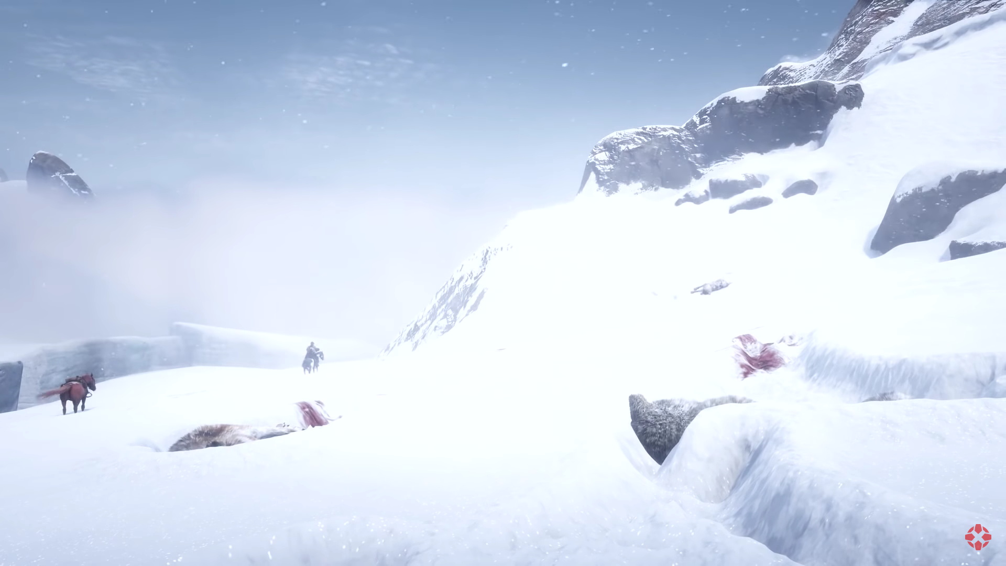
Figure 3: Uncommon environments like this mountaintop generally have lower-quality effects that are intentionally generic so that they can be re-used without repetition [6]
In contrast with the effects found in Mad Max, Red Dead Redemption 2 features a number of noticeable improvements in visual fidelity and realism, but otherwise rely on the same placed-and-scripted or generic-and-reusable paradigms. If developers were able to reduce the amount of overhead these weather systems require, effort could instead be directed towards visual fidelity and variety.

Methodology
This Thesis consists of both an Artifact and this document, which contains both an overview of the design and a simplified postmortem detailing the lessons learned during the creation of this thesis. The Artifact, “WeatherThesis Project,” is a UE4 project that implements the Weather Model design outlined in the Design section of this document, in addition to a rudimentary movement system used to preview the system in-engine.
The methodology section of this document contains a description of the tools and resources used in the creation this project, a summary of the deliverables and milestones of this artifact, and finally the means to evaluate how well the artifact demonstrates mastery of Technical Art.

Tools and Processes
The author met with her thesis advisor regularly, in order to discuss the project’s progress, getting help when stuck, and receiving advice and feedback.
The project was created using the programs Unreal Engine 4.20.3, Visual Studio 2017, and Adobe Photoshop CS6. Unreal and photoshop were chosen due to the author’s familiarity with these programs, as this would make it easier to focus less on the tools and more on the project itself. Visual Studio 2017 is the officially supported IDE of Unreal Engine 4.20, and thus was used to create the C++ source code for the project.

Deliverables and Milestones
Under the direction of the author’s thesis advisor, the author informally resubmitted her thesis proposal on November 20, 2018, where it was approved by her advisor.
The Design Document includes the detailed design of the weather model as a whole, as well as the mathematical formulas and scientific concepts used in the design and operation of the simulation. The rough draft of this document was approved by the author’s thesis advisor on November 29, 2018. and the final version was approved on March 1, 2019.
The Paper Prototype serves as an early proof of concept for the simulation. It accomplishes this by implementing the first-pass mathematical functions from the rough draft of the Design Document. Implemented in Microsoft Excel, this prototype demonstrates how the math will work, and viewers may change input variables to see the resulting output of the system. This prototype was submitted and approved on December 5, 2018.
The Artifact itself is an implementation of the core systems of the weather model design, as outlined in the Design section below. It consists of Unreal 4 Project files, C++ Source Code, and an assortment of sample bitmaps. The first-pass version of the artifact was submitted on February 25, 2019, and the final version was submitted to and approved by the author’s advisor on April 22.
DELIVERABLES | SUBMISSION DATE
Thesis Proposal Finalized | November 20, 2018
Initial Design Document | November 29, 2018
Paper Prototype Completed | December 5, 2018
Initial Artifact Prototype | February 25, 2019
Design Document Finalized | March 1, 2019
Final Artifact Submission | April 22, 2019
Thesis Paper Finalized, Submitted | May 2, 2019
Thesis Defense | May 2, 2019
Completed Thesis Submission | May 16, 2019

Defining Mastery
What it means to be a master of Technical Art is difficult to define in a solo-project, since Technical Artists’ greatest strengths lie in their ability to communicate and coordinate with the rest of the team. Technical Artists tend to specialize in a sub-discipline of Technical Art such as visual effects or shaders, but the very nature of the position as a go-between for the art, design, and engineering departments means that technical artists must also demonstrate a broad skillset, and above all, be able to combine these skills in the most effective manner appropriate for the task at hand.
Essentially, a master of Technical Art must be a jack-of-all-trades with a knack for coming up with creative solutions to complex problems. As a solo project, there are no complex problems for the author to solve, so she must create her own: in this case, attempting to create a new technology that aims to improve upon current design paradigms, a technology that lies at the crux of art, design, and software engineering, where a Technical Artist is most needed.

Design Overview
While the design of the weather model went through several changes over the course of developing the artifact, the core principles remained the same: the development of a realtime weather system that both spawns and controls the behavior of weather in a manner based on real-world meteorology and climate science. Below is an overview of the finalized design presented in this thesis.

Core Simulation
The Weather Model is a simplified version of the model used by meteorologists to predict the weather, in which virtual parcels of air are simulated by a computer to predict the development and behavior of weather phenomena.
This proposed Weather Model’s simulation is performed by a “Climate Volume” Actor, in concert with an “Air Parcel” component. the Climate Volume holds climate-specific data, such as humidity, the amount of water available at the surface, and the average wind vector within the volume, all of which are used in either the approximation of surface evaporation or in the behavior of air parcels. The Air Parcels mimic the behavior of dry air, accounting for the temperature, water vapor, and liquid water of the parcel. The Climate Volume handles the generation and overall management of the simulation, maintaining ownership of the Parcels and performing the operations that drive the simulation. The Climate Volume also serves as the primary user interface for control over the simulation within Unreal Engine 4, centralizing user-modified variables in a single location.
These two core classes serve as the basis for the Artifact – the other components of the Weather Model’s Design act as an extension of this core system. These proposed classes are pictured in the diagram below.
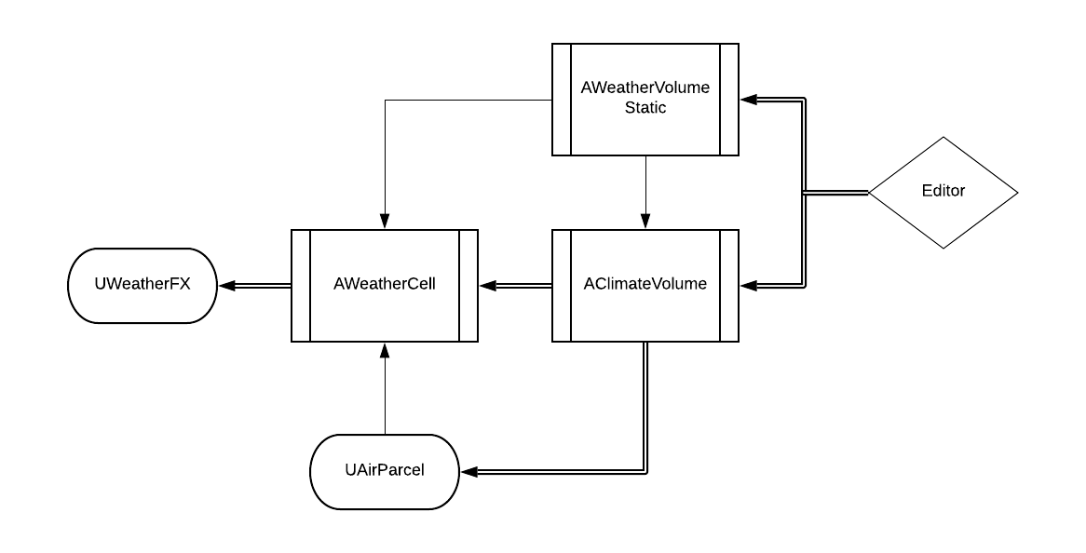
Figure 4: WeatherThesis Full Class Diagram: single lines indicate class dependency; double lines also indicate in-editor ownership.

Weather Simulation
A hypothetical “Weather Cell” Actor would control the internal simulation of storm cells and similar weather phenomena. Each weather cell contains a data structure that tracks the properties of a storm, including an array of temperature values, the quantity of water vapor, etc. These values are used to compute the shape of the weather cell: a dynamically generated mesh is generated when the cell detects that its values no longer represent the current shape. The shape generated is based on the anatomy of common cloud archetypes: the cell selects the closest match from a set of predefined templates, and then modifies it as necessary to account for any major discrepancies. This shape is not rendered by the engine; instead it is used as a volume in which to fill with Weather FX components, which hold the visible elements of the system. Finally, the hypothetical “Weather FX” component would be used as building blocks by Weather Cells to control the actual visual elements of weather, including clouds, precipitation, fog, frost, etc. The Weather FX components would be akin to a volumetric particle effect, the dimensions and intensity of which would be shaped and molded procedurally at runtime.
Each cell follows the natural cycle of cloud development, effectively a micro-simulation unto itself. Constantly burning the energy used in their creation, each weather cell will weaken and die off, without additional energy from climate volumes. Essentially, the cells have expendable momentum that the volumes can apply acceleration to.
Weather cells are designed to be independent of the climate volume simulation – they may pass freely from one volume to another and can even operate outside of climate volumes in their entirety. However, the primary method in which weather cells are spawned is via simulated condensation in the climate volume.
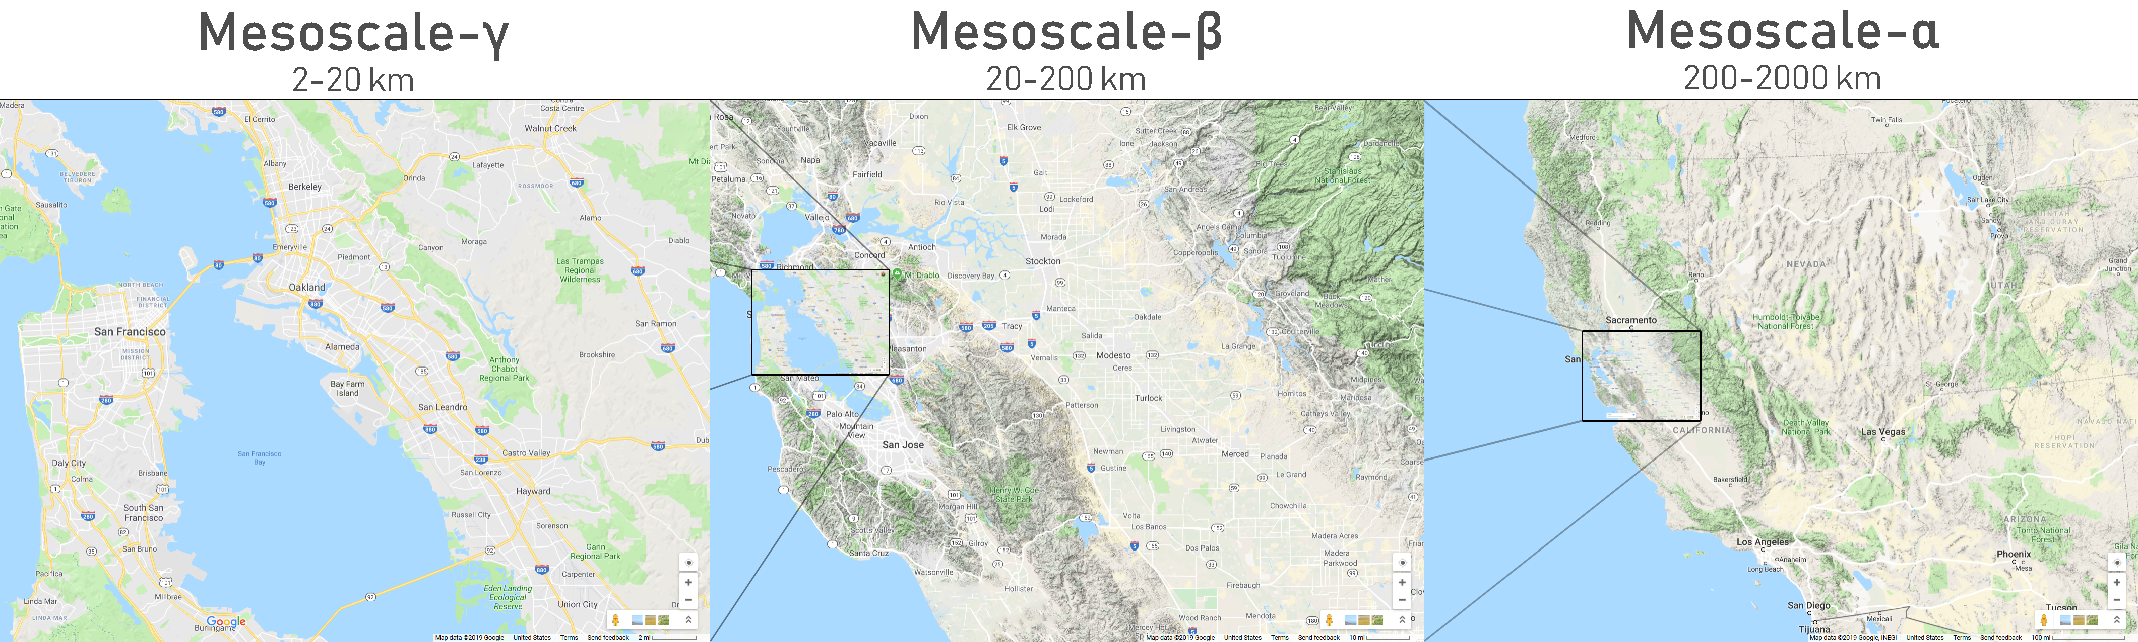
In the core simulation, when an air parcel has more water vapor than it can carry, it must relieve itself of this vapor through the process of condensation. In the fully integrated design, air parcels seek the nearest weather cell when condensing, and if one is not within a preset distance, a new weather cell is generated. If two weather cells are within a certain distance of each other, and are of a similar composition, they will merge, allowing the system to always use the minimum number of cells necessary for simulation.
Figure 5: The three subdivisions of Mesoscale Meteorological models
Unlike the air parcels within the core simulation, weather cells are directly managed by the engine, and have no inherent limit to their numbers, although this can be restricted at the discretion of the user.
With a large climate system implementation involving multiple climate volumes, this dynamic generation should accurately simulate weather. However, if there are few climate volumes, there may not be enough space for visible clouds to form, as cloud formation is typically a gradual process over great distances. In such cases, designers may spawn in weather cells manually.

Extended Class: Weather Volume
A hypothetical “Weather Volume” Actor would offer developers an additional level of control over the simulation within the Climate Volume in an intuitive manner. Weather Volumes modulate the behavior of air parcels within the overlap of the Weather and Climate Volumes. This manual manipulation of the otherwise autonomous simulation is to account for meteorological or topographical anomalies such as urban landscapes, volcanoes, geysers, narrow ravines, etc. The Volume can also be used to dynamically “induce” weather phenomena manually, for use in cinematics, scripted events, and other cases where manual control over the behavior of weather may be desirable.

Design: Weather Model Simplification
In the year 2019, realtime fluid dynamics simulation in video games is still a very young technology. Modern weather forecasting is done using weather models designed to be run by supercomputers, over a period of several minutes to several hours of computations. This necessitates the simplification of a ‘complete’ weather model, boiling it down to only the elements necessary for apparent realism, in order to create a dynamic system
In order to determine which elements can be simplified or ignored, the physical dimensions of the simulation are the primary consideration. Meteorological models are subdivided into different domains, based on the scale simulated. Each of these domains focuses on one or more systems that are most relevant at their respective scale.

The Synoptic scale is physically the largest domain, covering areas as large as entire continents, and focuses on the formation and interactions between pressure zones and storm fronts. Microscale, the smallest, covers an area of one kilometer or less, and primarily concerns the discrete heat transfer and gas exchange of air, bodies of water, and other types of terrain. Of greatest importance to this thesis, however, is the Mesoscale.
Mesoscale Meteorology consists of the generation and behavior of weather phenomena directly observable to the naked eye and can be further subdivided into three sub-domains. Mesoscale-α, focuses on the formation and behavior of squall lines, groups of storms that form along the edge of a cold front. Individual thunderstorm formation and behavior is modeled at the Mesoscale-β subdomain. Finally, specific subsections of a thunderstorm, such as updrafts and precipitation, are described by Mesoscale-γ meteorology.
To a layperson, the most directly observable and relevant meteorological domain is the Mesoscale-β domain, followed by the Mesoscale-γ domain. As such, these domains are at the center of this thesis’ weather model. Each degree removed from these domains can be simplified further, with many of the outlying phenomena, such as pressure fronts and discrete heat transfer, can be completely ignored.
To further facilitate simplification, the overall weather model is split into two separate simulations, likewise separated by meteorological domain. While both halves of the model utilize the same underlying scientific principles, each prioritizes different sets of data, and each has different allowances for approximation. Because something critical in one half may be trivial in the other, these separate systems are limited in their ability to affect one another, using an object-oriented methodology.
The primary simulation, or “Core Simulation,” deals with Microscale to Mesoscale-γ elements, with a balanced focus on speed and accuracy of simulation. This simulation involves the “Climate Volume” and “Air Parcel” classes.
The secondary simulation, “Weather Simulation” deals with Mesoscale-β elements and dedicates most of its resources to the visual fidelity of weather phenomena. This simulation involves the “Weather Cell” and “Weather FX” classes.

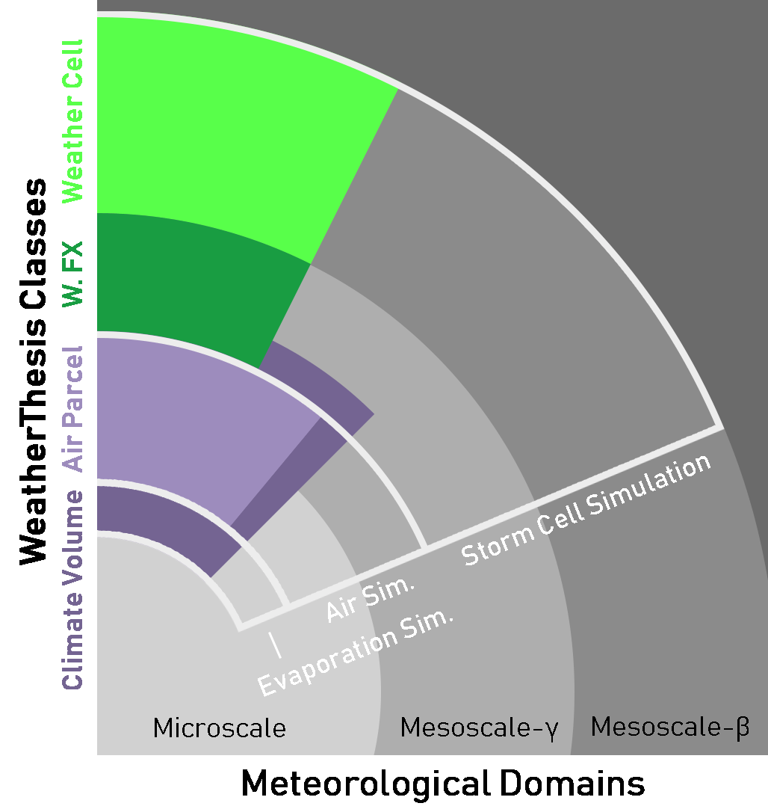
Figure 6: Class-Object Diagram, and their correlation to Meteorological Domains

Design: Climate Maps
Domain | Elements
Synoptic | Pressure systems, Temperature Fronts
Mesoscale-α | Supercells, squall lines, hurricanes
Mesoscale-β | Large clouds, thunderstorms, fog
Mesoscale-γ | Updrafts, downdrafts, precipitation
Microscale | Evaporation, transpiration, percolation
Object | Elements
Core Simulation (Climate Volume, Air Parcel) | Updrafts, downdrafts, evaporation, (precipitation affected)
Weather Simulation (Weather Cell, Weather FX) | Large clouds, thunderstorms, fog, precipitation
One of the more complex design considerations was the method in which to initialize the simulation state, something that would require an immense amount of data, data that must be set by users manually. An existing game development technology, “Normal Maps” presented a novel and effective solution for accomplishing this without compromising on the effectiveness or usability of the system. Normal Maps are bitmaps that contain lighting information in each color channel. Each channel effectively constitutes a two-dimensional integer array; with the channel’s bit depth serving as the integer size (uint8 vs uint16).
User-created “Climate Map” bitmaps utilize both the methodology of normal map creation and the benefits thereof. Just as in a normal map, climate maps are effectively a set of two-dimensional integer arrays. There are quite a few benefits to this approach to initialization. First and foremost is the intuitive nature of the system, data is easy to understand and preview in-editor, as the Climate Maps are literal maps. Second, unlike csv files and similar array storage methods, bitmaps can take advantage of the powerful tools available in image-modification software to make the creation and modification of large amounts of data significantly easier to implement. Finally, by basing the design on well-known existing technologies, the asset-pipeline is more easily predictable and manageable.

Methodology
Initial designs for these maps were centered around the use quantifiable data in each channel, such as vapor mass and temperature gradients, as these values would be the easiest to modify mathematically. However, the vast majority of these quantifiable data types are difficult to visualize intuitively, instead requiring a thorough understanding of climate science to utilize properly. As such, the design was re-centered around more intuitive values that can be understood by laypersons.
For example, one of the original data sets was “Absolute Humidity”, a quantifiable measurement of the amount of water vapor in the air. While this value is trivial for a scientist to measure with specialized equipment, it is not something that can be directly observed by human senses. In humans, what we typically characterize as “humidity” is in fact the “Relative Humidity”, which is in turn a function of the Absolute Humidity and the current temperature. By using the more intuitive Relative Humidity, it becomes easier for users to read and understand climate maps.
In addition to the intuitive benefits of this approach, it ensures that each channel can be modified independently of the others without risking unintended effects. For example, a change in Absolute Humidity could cause a physically impossible state that breaks the simulation, depending on the value of the Temperature channel. Relative Humidity, on the other hand, is a percentage value that inherently is limited to realistic values.

Structure
There are two types of Climate Maps: the Surface Map and the Atmospheric Map. Functionally, they are nearly identical: they are instead distinguished by what properties their channels are used to depict. Each utilize the three 8-bit non-alpha channels of a 32-bit bitmap, with a resolution restricted only to square shapes. Each channel depicts a single percentage value, stored as an 8-bit integer.
In both the Surface and Atmospheric maps, the Red channel is a depiction of average temperature, as a percentage of the minimum and maximum values that the simulation can accept. The minimum temperature, -20° Celsius, is represented by a value of 0x00 (i.e. 0% White), and the maximum temperature, 60° Celsius, corresponds to a value of 0xFF (i.e. 100% Black). This means that a value of 0x7F (50% Gray) corresponds to a temperature of 20° Celsius, which is close to the average yearly temperature within temperate zones.
In the Surface Map, The Green channel represents the ratio of water to land, including capillary water held above the groundwater layer, as well as dense and/or large vegetation, which can also contribute to the amount of moisture available for evaporation. Completely dry areas, such as extreme desert, would have a value near 0%, while nearly any body of water would be 100%. The Surface Map’s Blue channel is a cruder approximation of water to land, but one that only considers groundwater, and is merely an approximation. While natural bodies of water would still have a value at or near 100%, shallow, manmade water sources would not. An additional consideration for the Blue channel’s approximation is the accessibility of groundwater: groundwater that is especially deep or covered by large manmade structures will have a lower approximated percentage.
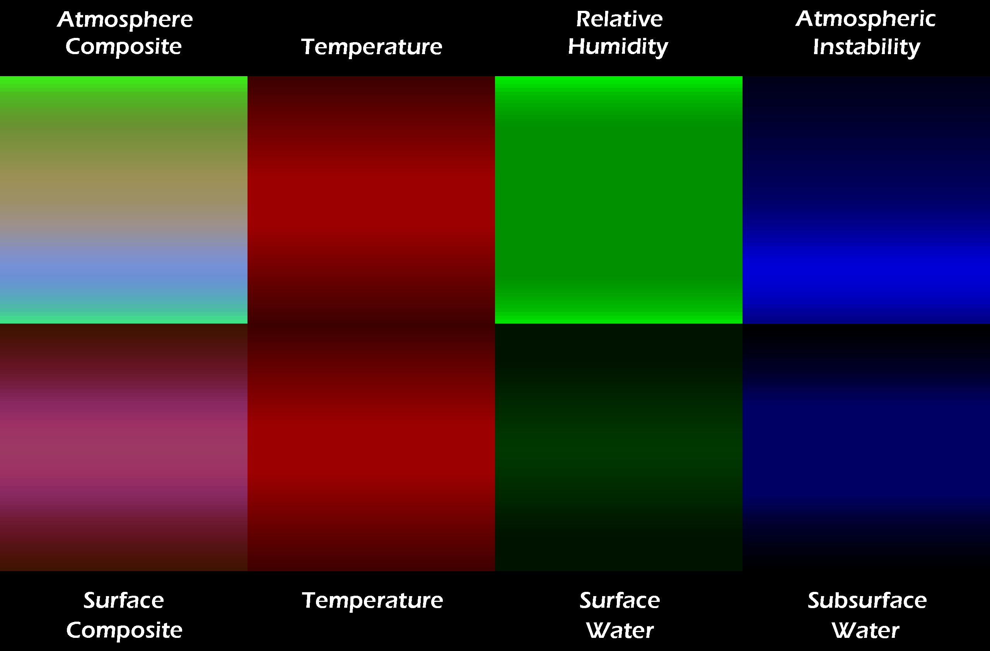
Figure 7: An example of an Atmospheric and Surface Map, in this case representing a forested east-west valley
In the Atmosphere Map, the Green channel represents Relative Humidity, the percentage of water vapor currently held by the air compared to the maximum amount it could hold at the current temperature. The simulation does not directly use this value; instead, Absolute Humidity is derived from this channel along with the Red channel when a parcel is created, as the parcels themselves only use quantifiable data, and not percentage values. The Blue channel of the Atmosphere Map depicts Atmospheric Instability. Instability measures the homogeneity of the atmosphere’s composition, which furthermore determines the magnitude of vertical movement within the air. Similar to the Green channel, this value is not used directly in simulation, but is instead used during parcel spawning to create a state that approximates this value. Instability lacks a single, standardized unit of measurement: as such, the percentage value ascribed to this channel is an arbitrary range: 0% represents complete homogeneity, while 100% means that the initial density of parcels will vary from half to double their original value.

Creation
Like normal maps, Climate Maps are intended to be created in image-editing programs such as Adobe Photoshop. Similar to normal maps, bump maps, and other such data-oriented bitmaps, Climate Maps can be created from external data or painted from scratch, or, more often, a combination of the two approaches.
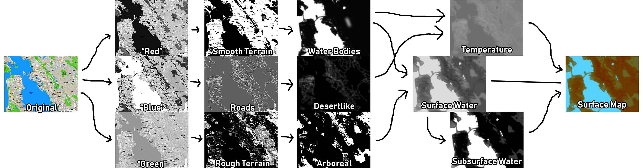
Figure 8: Splitting a map into individual channels
Typically, the first steps of creating a climate map is to get actual topographical maps. While it is possible to find precise data such as temperature maps or groundwater maps, simple maps will usually be sufficient, if manipulated via image-editing software. In the example above, a map of San Francisco, taken from Google Maps, serves as the initial template for our surface map, and the map is immediately condensed and separated by channel into three black and white images. While not a required step, separating the channels into separate layers makes it easier to modify non-destructively.

Figure 9: Creating specific data from raw channel data
By referring to the original map, certain elements can be isolated in separate layers using filters and other tools. In the example below, the original, arbitrary channel data gets distilled into usable information in Photoshop CS6. The red channel is used to identify bodies of water via the use of the Levels, Curve, and Brush tools. The blue channel is used first to isolate roads via the Curves Tool, and then extrapolates an approximation of urban sprawl using the Levels tool and the Gaussian Blur filter. Finally, the green channel approximates rough terrain using the Curves and Levels tools, and then is further filtered to forests only, using the Brush tool. These crude data maps can be combined to create the actual data needed, based on a rudimentary understanding of climate science.

Figure 10: Creating Surface Map channels from climate data
The final step is to re-composite the channels back into a single image, in this example resulting in a Surface Map.

Figure 11: Creating the finalized Surface Map

Performance Guidelines
One of the primary differences between the Atmosphere Map and the Surface Map is how they impact Core Simulation performance. The Core Simulation consists of two data structures: Air Parcels and Surface Clusters. Both are generated at level-load, and they correspond to the Atmospheric and Surface Maps, respectively. Regarding Air Parcels, the Atmospheric Map is performance-agnostic, only slightly affecting the load time, while leaving runtime performance entirely unaffected. Thus, it is generally best practice to use the highest resolution possible, up to 2048 x 2048 pixels. Unlike the Atmospheric Map however, the Surface Map has a fair impact on performance.
The resolution of the Surface Map determines the number of Surface Clusters generated, and thus load time increases linearly with Surface Map resolution. Furthermore, the number of Surface Clusters also increases the complexity of the Core simulation’s Evaporation pass, albeit slightly less than linearly. As this performance hit is solely based on Surface Map resolution, it is best practice to use the smallest resolution possible. While the system supports a minimum resolution of 8 x 8 pixels, this resolution may not be sufficient for areas with complex topography, and as such, users must either increase the resolution, or split the area into multiple climate volumes.

Future Applications
Currently, the two types of Climate Maps use 3 8-bit channels of a 32-bit bitmap, which means there is an 8-bit alpha channel currently unused. This leaves room for the addition of and additional data channel in the future, should it be warranted. Hypothetically, the system could also be expanded to support higher bit-depths, but the author estimates that 8-bit depth should offer sufficient data granularity for this simplified weather model.

Artifact
The artifact is an implementation of the core components of the Weather Model: the Climate Volume Actor and the Air Parcel Component. This section elaborates upon the Design section’s description of these two classes in order to explain their inner workings in further detail.

Air Parcel Component
The Air Parcel is designed to only be accessible to its owner, the Climate Volume. Parcels are assigned an initial mass and volume based on the size of the Climate Volume and the number of parcels in the system. The other variables tracked include water vapor mass, temperature, and the distance the parcel moved vertically the last time it moved. All values are initialized by the owning Climate Volume, and all mathematical calculations are likewise performed by the owner. The only other function of Air Parcel components is their collision sphere. In real life, all things generally affect all other things, with the magnitude of such effects modulated by the distance between these objects. As a simplification of this concept, each parcel has a collision sphere that acts as a binary cutoff for elements that should and should not be considered in their behavior. Effectively, each parcel only affects adjacent parcels.

Climate Volume Actor - Simulation
While the Air Parcels store data, the actual math is done by the Climate Volume. This process runs each tick, offset by a frame skip value. It can be broken down into 4 phases: The Solar Phase, the Adiabatic Phase, the Condensation Phase, and the Movement Phase.
The surface of the attached landscape is divided into subsections referred to as “Surface Clusters,” these clusters are the primary focus of the Solar Phase. In the real world, all weather is ultimately driven by the energy of the sun being absorbed by the earth’s surface – without this additional energy, weather would first disappear as the air became homogenous, and then the earth would slowly freeze as its energy is slowly released by the upper atmosphere into space. Based on the time of day, latitude, and current weather conditions, each cluster updates its temperature based on the amount of sunlight calculated to reach it over the course of the previous tick. Once this is complete, each cluster evaporates moisture and heat into the atmosphere, grabbing the nearest available parcel and updating its water vapor and temperature values.
Phase 2 is the Adiabatic Phase. The Adiabatic Process is the result of a parcel of air being heated or cooled, which results in a change in the parcel’s volume, density, and buoyancy. During this phase, each parcel has its temperature and volume adjusted according to the distance it moved during the previous tick. The density and buoyancy are not calculated during this step, as these values are only generated in a future phase, and only if necessary.
Phase 3 is the Condensation Phase, where parcels with excess moisture release it. In both meteorological weather models and this simplified model, the maximum amount of water vapor that a parcel of air can be determined with the parcel’s temperature, the mass of its dry air, and the current mass of its water vapor. As the air parcels in this simplified model all have a constant air mass, only the temperature and vapor mass are necessary for this calculation. When an air parcel is fully saturated with water, any additional water vapor will condensate into liquid water. Likewise, a decrease in temperature may also cause water vapor to condensate, as the temperature serves as a multiplier for how much water vapor a parcel can hold.
The final phase is the Movement Phase, where the height of each air parcel is adjusted based upon its buoyancy, as well as topographical factors that may restrict the movement of said parcels. While the buoyancy of air may be precisely calculated with the Archimedes Formula in combination with the Renault Formula, this level of complexity is unnecessary for a simplified weather model.
The reason that the buoyancy of air is such a complicated matter is because of the presence of water vapor, the air essentially becomes a mixture of mixtures, a state that makes realtime simulation difficult without further simplification; such a calculation would necessitate the use of nested for loops, an O(n²) function that would be impossible to implement in realtime with any significant number of parcels. Instead of this full-precision method, this model implements a trick used in meteorological shorthand: virtual temperature. Within the narrow range of temperatures normally found in the lower troposphere, the effect of water on the buoyancy of air is fairly predictable; it can be converted into a “virtual temperature”, which when combined with the dry air mass of an air parcel, is used to approximate the of buoyancy of the parcel. This simplification effectively reduces an O(n²) function into an O(n) function, which is significantly more suitable for a realtime calculation. After the buoyancy is determined, each of the parcels are tested against each other, and their world position adjusted.
This adjustment is determined by four factors. The first factor is the movement vector of the parcel due to relative buoyancy. The second factor is the force of wind being applied to the parcel. The third factor, the length of time allotted to the parcel for movement, is based on the amount of time that has passed since the parcel last moved; this allows parcel movement to be completely uncoupled from framerate, even though the underlying simulation is not. Finally, the fourth factor is collision testing for items that would restrict the movement of air, such as landscape, large buildings, or other large-scale obstructions. If such collision occurs, an additional calculation takes place to adjust the movement of the parcel so that it adapts to the shape of the object it collides with.
After the Movement Phase completes, the cycle begins again with the Solar Phase.

Climate Volume Actor – Designer Control
The Climate Volume serves as not only the primary controller of the simulation, but also the primary user interface for designers and artists to control the behavior of the system. The vast majority of exposed, modifiable simulation variables are kept here. This centralized design makes it easier to tweak the behavior of each volume, additionally making documentation more manageable. In the Unreal 4 Editor, these exposed variables are sorted into one of three categories: Simulation Performance, Climate Behavior, and Climate Initialization.

1) Simulation Performance Properties
Simulation Performance properties allow designers to tweak the performance and accuracy of the simulation; it is here that the total number of discrete parcels is set,
as well as the number of frames that are skipped to allow for the smoothing out of performance spikes.

2) Climate Behavior Properties
The Climate Behavior category contains many properties, all of which are optional: they each are set to a sensible default value that can be modified by a designer if desired. These properties include items like the wind speed and direction, the time of day, and the latitude of the volume.

3) Climate Initialization Properties
Climate Initialization is the most complex of the three categories from the perspective of a user. The properties in this category are few but critical, as they form the basis of the entire simulation. The Climate Volume is designed to be attached to UE4 Landscape actors, so that it can access data about the topography of the level. Within the initialization category, there is an indicator that lists which landscape actor, if any, the volume is attached to, as well as a selection tool that makes it easy to snap the landscape directly to the edges of a landscape actor.
In addition to the landscape snapping tool, there are two more properties within the Climate Initialization section: the Atmospheric Climate Map and the Surface Climate Map. As described in the previous section, these provide the Climate Volume with the bulk of initialization data, made compact by utilizing designer or artist-made bitmaps.

Climate Volume Actor – Advanced Controls
In addition to the editor-exposed properties, a second group of properties within the Climate Volume’s source code are also available for modification, grouped together in a single section in the Climate Volume Actor’s header file. These properties were intentionally not exposed to the Editor; As they affect the inner workings of all climate volumes globally, and in dramatic fashion, they would be dangerous to leave exposed to everyone with access to the level editor. Hiding them a layer deeper, in the source code, is the best way to ensure simulation integrity without entirely sacrificing additional user control.

Postmortem
The author began this thesis in early September 2018 by exploring possible topics for this thesis in-depth. In November, this topic was selected, and work began immediately on the design of the system.
Throughout December, the initial design took place: the overall structure of the final design is virtually identical to the initial design, however there are significant differences in implementation. The design process itself went seemingly smoothly, but a procedural mistake during this process created an issue that did not become apparent until months later.
The initial artifact design called for the implementation of the entire simulation design, a decision that would later be recognized as being outside of the scope of this thesis; thus, the artifact design was trimmed down to just the two central components, the Climate Volume and Air Parcel.
Because of this initial over-scope issue, the first half of the thesis process had significantly less focus on testing than the latter half, accruing technical debt from the insufficient quantity and rigor of testing. As a result of this debt, a persistent, undocumented, and complex Unreal 4 Engine bug halted all progress in the month of March.
The bug initially presented itself as pre-generated data getting zero-filled at runtime, but further testing revealed the bug to be a significantly more complex issue. The core of the issue lies in the way in which the engine handles in-editor dynamic generation.
UActorComponent objects, unlike all other UObject-derived C++ classes, cannot permanently save primitive data types if they were instantiated by an external C++ class. This means that the editor-generated Air Parcels would initially appear to work correctly, but lose all their climate data when attempting to run, regardless of UProperty specifiers or data structure. The Air Parcels themselves were correctly being serialized and saved, as were all of their UObject-derived child components, but the native int and float variables were lost into the ether for unknown reasons. In the final workaround, generation timing was moved from in-editor to at-load, as there would be no need to save any of these values during the runtime itself.
Although it took weeks to solve this problem, it would have been trivial to fix had it been identified earlier in development. Accounting for technical debt will be an important factor in the design of future projects: early testing must be especially frequent and thorough if the project is to have a solid foundation. The rest of the project proceeded smoothly, with the final artifact completed and submitted in April.

Analysis
As a proof-of-concept design, the artifact is intended primarily as an approximation of what a hypothetical full-implementation would be like, serving as a sort of vertical slice of the complexity of design, user-interface, and the performance of the simulation as a whole. These three areas are what the author will examine to evaluate the viability of this theoretical design.

Design Complexity
The final design complexity of the artifact was significantly larger than initial estimations indicated. This is due to the way in which the systems needed to be designed; while overall, the simulation was based on real-world mathematical formulae, optimization for use in games necessitated the simplification of specific areas. This simplification process was difficult to implement, as there were numerous pieces of the design that relied upon each other; any large inaccuracies would effectively ruin the behavior of the entire simulation. The individual designs themselves are straightforward, but the process necessary to arrive at these designs is complex.

User Interface
The user interface (UI) of the artifact is nearly identical to the original, full weather model’s design. The artifact implements the core systems of the weather model design, including the user interface, and over the course of the project, the UI continued to improve and evolve with each iteration. The principal focus of the UIs design is usability: each property should only be available as necessary, and each must feel intuitive for a designer to use, along with sensible naming conventions, widgets, and tooltips.
Properties are grouped by feature category in the Editor: the simulation settings, the climate settings, and the optional settings. Each category begins collapsed in-editor and can be expanded as-needed; this keeps the interface small and readable.
In addition to the organization and simplification that was done to the inputs, a rudimentary output display was implemented, providing designers information about the internal state of the Climate Volume at a glance, without having to resort to debug messaging, or clogging up the system log. This output display contains only the most critical information, so as not to take up too much space in the interface itself.

Performance
The final measure of the artifact is one of the most important, but also the most speculative. As the artifact does not implement the entire weather model design, current performance statistics do not precisely reflect the performance such an implementation would exhibit. That being said, what has been implemented is by far the most complex and computationally expensive aspect of the overall design, and as such, current performance data may be used to roughly estimate the general magnitude of this performance impact.
The core system runs within the expected range of the original design; The Big O notation of the simulation loop is O(f(n)), meaning the performance of this system grows linearly with the number of parcels being simulated. At the demonstration size of 2 square kilometers, at a nominal resolution of 128 parcels per square kilometer, the simulation, without debug visuals, runs at a speed of 7 milliseconds per tick. Further tests confirm that performance does indeed conform to a linear trend of ≈ 0.3 milliseconds per parcel per kilometer, as seen in the figure below.

Figure 13: Performance impact of the Core Simulation, as a function of parcel-density
The author estimates that the minimum resolution possible, without breaking the simulation, lies at 32 parcels per square kilometer, which would have a theoretical maximum performance impact of 9.6 ms/km.
Considering that this artifact is a largely un-optimized proof-of-concept, the author postulates that this level of performance indicates that an optimized implementation may indeed be viable for the current generation of consoles.

Conclusion
This project has a twofold purpose: to propose and prototype a new technology, and to demonstrate mastery of Technical Art through that new technology.
As a Proof-of-Concept demonstration for a new technology, the artifact succeeds at proving the overall design worthy of further research and development. The performance testing of the current system confirms the author’s hypothesis that a system of this nature may be commercially viable within the next few years.
Likewise, the author displays mastery of Technical Art through the artifact and design documentation. This mastery is demonstrated by the multidisciplinary nature of this technology: a hybrid of simulation and visual effects technologies, one designed around being intuitive for artists and designers to use in the UE4 Editor with minimal hassle.
As computer hardware continues to improve, video game technology gains new footholds to latch on to, new techniques to utilize. Progress is made not only in the incremental improvement of existing technology, but also through the introduction of new ideas. It is these ideas that sometimes drastically alter the paradigm, redefining the way we think about a specific aspect of video game development. It is the author’s hope that this project serves as yet another stepping stone for the ever-forward march of video game technology.

References
[1] Mad Max. (Multiplatform). USA: Warner Bros. Interactive Entertainment, Sweden: Avalanche Studios, 2015. [Video Game].
[2] Technopippo. (Apr. 30, 2019). Mad Max Weather. YouTube, 2015. [Web Video]. Available: https://www.youtube.com/watch?v=XkZ1DbHK5sY
[3] SociopathicSeahorse (sic) Productions. (May 1. 2019). Mad Max – Weather Gameplay. YouTube, 2015. [Web Video] Available: https://www.youtube.com/watch?v=xNoAJ4-YbUM
[4] Red Dead Redemption 2. (Multiplatform). USA: Rockstar Games, Rockstar Studios, 2018. [Video Game].
[5] 8-Bit Bastard. (May 1, 2019). 7 Days in Red Dead Redemption 2 | 7 Day Cycle Time Lapse. YouTube, 2018. [Web Video]. Available: https://www.youtube.com/watch?v=v3gcd54_XpY
[6] IGN. (Apr. 30, 2019). Red Dead Redemption 2: The Beautiful and Terrifying Weather System. YouTube, 2018. [Web Video]. Available: https://www.youtube.com/watch?v=j9oBYS0Xor4

